Written Assignment
Student’s Name
Institution of Affiliation
Professor
Date

FIT190wri
A1
- American College of Sports Medicine (2020). An International Consensus Statement on Physical Activity and Mental Health Just Released. Retrieved from https://www.acsm.org/
- American College of Sports Medicine (2020). Consensus Statement Published from the 19th Annual Team Physician Consensus Conference. Retrieved from https://www.acsm.org/
- American Heart Association (2020). Getting Physically Active. Retrieved from https://www.heart.org/en/health-topics/cardiac-rehab/getting-physically-active
- American Public Health Association (2020). Improving Health and Wellness through Access to Nature. Retrieved from https://www.apha.org/policies-and-advocacy/public-health-policy-statements/policy-database/2014/07/08/09/18/improving-health-and-wellness-through-access-to-nature
- American Society of Safety Professionals (2019). Three Keys to Improving Risk Management. Retrieved from https://www.assp.org
- American Society of Safety Professionals (2020). PPE in Healthcare: How to Prevent Exposure and Contamination. Retrieved from https://www.assp.org
- CrossFit (2020). Aseem Malhotra: Lessons in Public Health Advocacy. Retrieved from https://www.crossfit.com/health
- Centers for Disease Control and Prevention (2020). Sports Safety. Retrieved from https://www.cdc.gov/safechild/sports_injuries/
- De Souza, M. J. & Williams, N. (2020). The Female Athlete Triad. Retrieved from https://www.acsm.org/
- Elixhauser, A. & Weiss, J. A. (2016). Sports-Related Emergency Department Visits and Hospital Inpatient Stays, 2013. Retrieved from https://hcup-us.ahrq.gov/reports/statbriefs/sb207-Sports-Hospital-Emergency-Department-2013.jsp
- Global Health Council (2020). “First do no harm”: Why water, Sanitation and hygiene must be a priority for quality healthcare, protecting patient safety and tackling AMR. Retrieved from https://globalhealth.org/event/first-do-no-harm-why-water-sanitation-and-hygiene-must-be-a-priority-for-quality-healthcare-protecting-patient-safety-and-tackling-amr/
- Global Health (2015). Workers’ Guide to Health and Safety. Retrieved from https://globalhealth.org/workers-guide-to-health-and-safety/
- Green, D. J. (2020). ACE-Sponsored Research: A Comparison of Energy Expenditure when Exercising on 10 Indoor Exercising Machines. Retrieved from https://www.acefitness.org/education-and-resources/professional/certified/january-2020/7441/ace-sponsored-research-a-comparison-of-energy-expenditure-when-exercising-on-10-indoor-exercise
- Shannon, F. (2020). Prepping Programming for 2020: How to keep workouts fresh in the New Year. Retrieved from https://www.acefitness.org/education-and-resources/professional/expert-articles/7451/prepping-programming-for-2020-how-to-keep-workouts-fresh-in-the-new-year
- Smith, G. (2007). Going for the Gold: Using Sports Psychology to Improve Teaching and Learning. Retrieved from https://www.psychologicalscience.org/observer/going-for-the-gold-using-sports-psychology-to-improve-teaching-and-learning
- Stanhewicz, A. & Greaney, J. (2020). The Sympathetic Nervous System and Vascular Health. Retrieved from https://www.acsm.org/
- United States Department of Labor (2020). Grain Handling. Retrieved from https://www.osha.gov
- U.S. Department of Health & Human Services (2018). President’s Council on Sports, Fitness & Nutrition. Retrieved from https://www.hhs.gov/sites/default/files/PCSFN%20Annual%20Mtg%20Minutes-09.21.18-FINAL.pdf
- World Health Organization (2020). Adolescents: Health Risks and Solutions. Retrieved from https://www.who.int/en/news-room/fact-sheets/detail/adolescents-health-risks-and-solutions
- World Health Organization (2019). World Mental Health Day 2019: Focus on Suicide Prevention. Retrieved from https://www.who.int/news-room/events/detail/2019/10/10/default-calendar/world-mental-health-day-2019-focus-on-suicide-prevention
A2
The renowned psychological impact of signs on the participants is that signage helps to promote social interaction and helps the participants to improve their self-esteem (Young et al, 2013). This alone is a factor that has helped in reducing the symptoms of depressive illness among the participants who rely on sign language. The use of signage in sports and the resultant improved participation in physical activity has been shown to tremendously improve the psychological health of the participants and this is especially true for the team sporting activities (Young et al, 2013).
Signage plays a role in lessening liability and promoting safety by way of indemnifying the owner of a sporting facility by way of providing prior and prompt warning for the participants. By way of communicating the language of safety and if properly position on a work site, or on a machinery, the availability of the signage can be used by the defendant to claim no responsibility on what transpires on his property should anyone get hurt by the same machinery or work hazard on the facility and chose to sue the owner of the facility. This is highly applicable in the law courts as a defense for the defendant given that the signage was clears, correctly and timely placed on the site that might prove to be a hazard to others (Tikriti, 2020).
In addition to audio announcements, other elements such as text can be used to communicate and reinforce signage in promoting safety and lessening liability. The signs could be created in 3 Dimension so as to enhance the visibility of the signs and in so doing help to reinforce the message being passed along. If signs are to be displayed on some sort of screen, animations or short videos could be used to enhance the message being communicated.

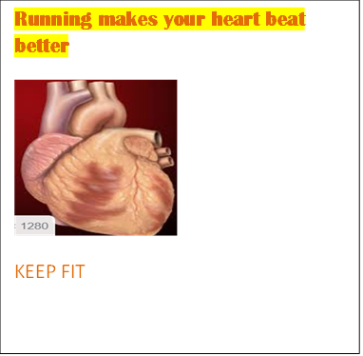
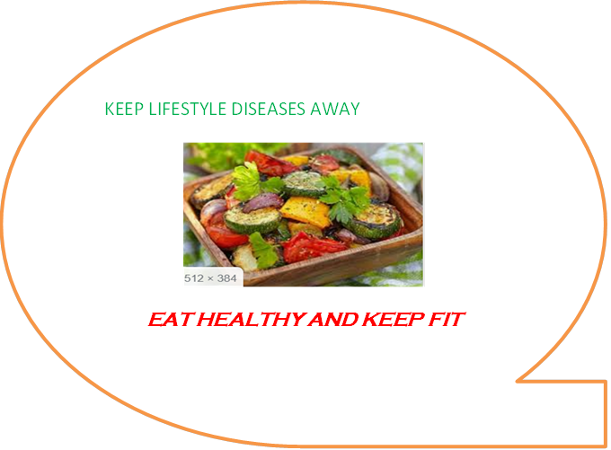
HCM308ex1
A3
The pharmacist was charged with reckless homicide and involuntary manslaughter, a charge that has warranted him to be incarcerated for six months (Mattingly, 2010). The charges were brought against the pharmacist by the state in which he worked given his position at the hospital in question as the pharmacist in charge who was supervising the technician who did the actual mistake. Both the state for which he worked for and the parents of the deceased baby girl would have standing to sue the pharmacist on account of the actions of the technician who he was supposed to be supervising. The tort lawsuit that could be brought against the pharmacist is Negligence. It has been determined under “standard of care” that “negligence is the failure to exercise that degree of care which an ordinary prudent person would exercise under the same or similar circumstances to avoid injury to another” (Supreme Court of Virginia, 1995). The availability of “Proof Beyond a Reasonable Doubt” is the standard of proof required to obtain a conviction in a criminal case but some country also apply a second standard that is: Preponderance of the Evidence. This applies better when it comes to the burden of proof. The burden of proof required to win a judgement in a civil case refers to the requirement that the plaintiff show by a “Preponderance of the Evidence” or “weight of evidence” that all facts necessary to win a judgment are presented and are probably true. In a civil case, the burden of proof does not only fall on the prosecution side alone. In the absence of a vital fact, referred to as an “element of the cause of action”, then the decision of whether the plaintiff has met their burden of proof falls solely on the jury or the judge (Legal Dictionary, 2020).

References
Legal Dictionary (2020). Burden of Proof. Retrieved from https://dictionary.law.com/Default.aspx?selected=109
Mattingly, D. (2010). Teary Druggist Jailed in Death (video file). Retrieved from https://www.youtube.com/watch?v=iru56ZO9tKc
Supreme Court of Virginia (1995). Gossett v. Jackson, 457 S.E.2d 97 (Va. 1995)
Tikriti, A. (2020). A Clear, Legible, Well-Placed Warning Sign can provide Owners some Protection from Liability for Injuries on the Premises. Retrieved from https://www.alllaw.com/articles/nolo/personal-injury/warning-sign-affect-liability-property-owner.html
Young, A. J., Eime, M. R., Harvey, T. J., Melanie, J. C. & Rayne, R. W. (2013). A Systematic Review of the Psychological and Social Benefits of Participation in Sport for Children and Adolescents: Informing Development of a Conceptual Model of Health through Sport. International Journal of Behavioral Nutrition and Physical Activity, 10(93)

